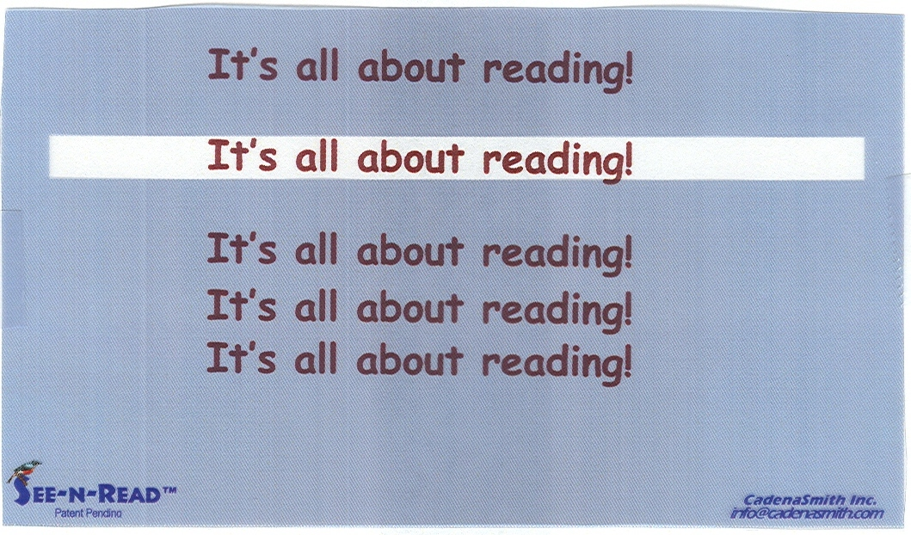
Reading Tools
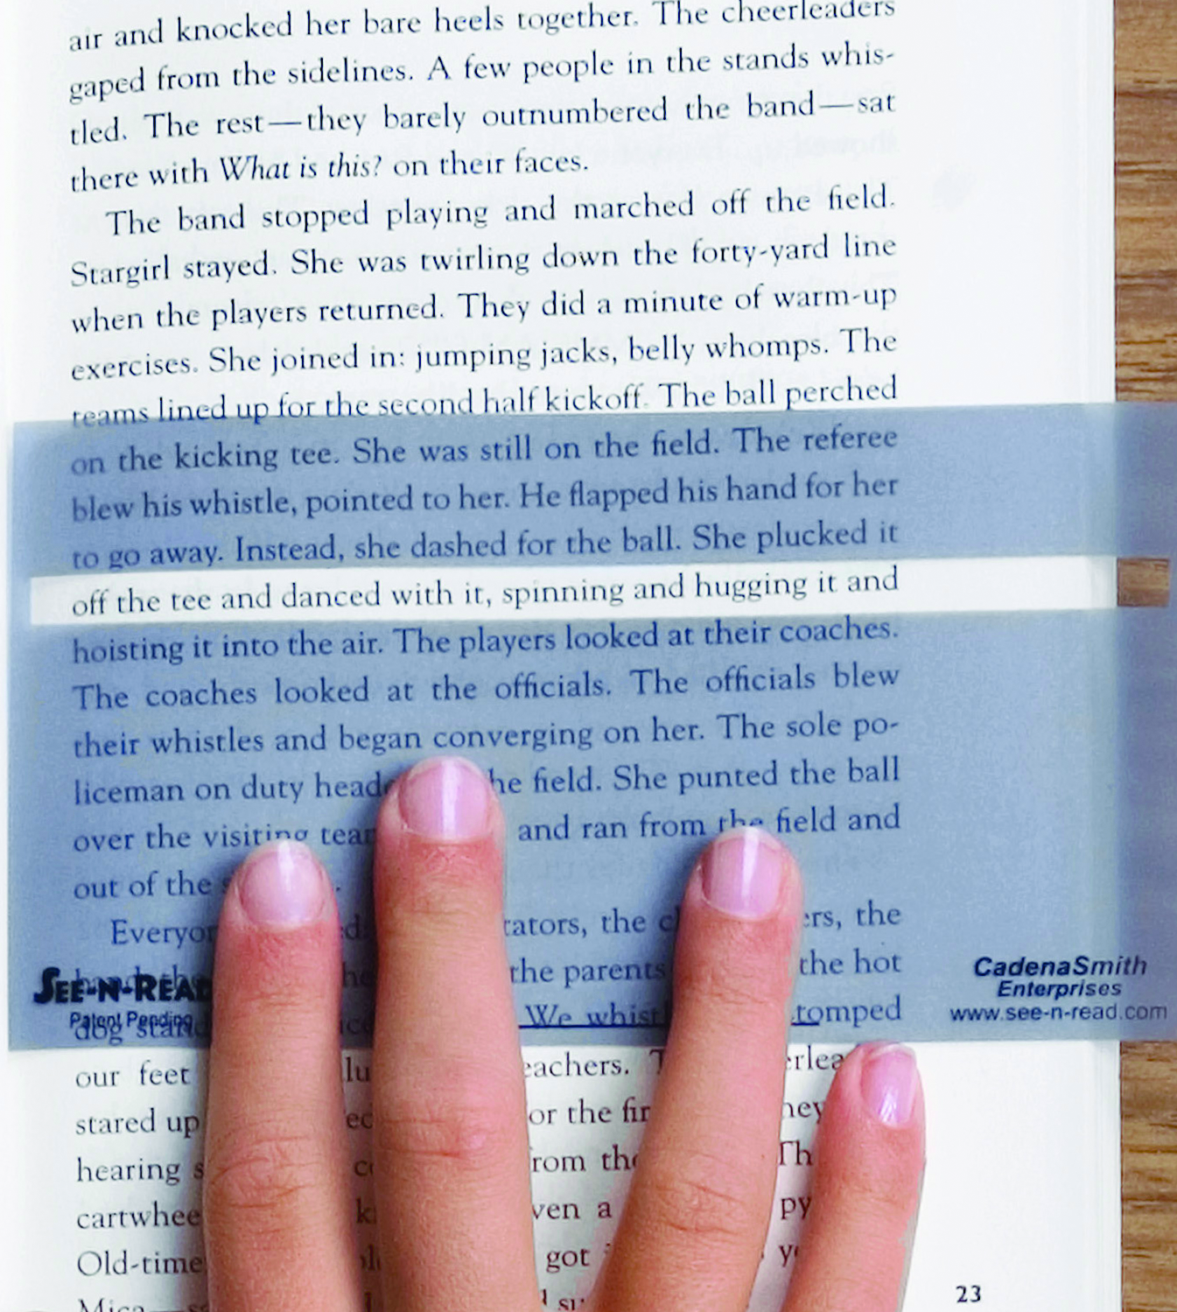
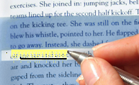
®
See-N-Read® original
MemoryMark™series

See-n-Read® Reading Tools Improve Fluency and Comprehension
Endorsed by reading professionals: neuropsychologist, bilingual reading specialist, classroom teachers
Features | Benefits
Universal Design (patent pending) | - Can be effectively used by the broadest population (K - Adult) with the least amount of manipulation or change required of individuals
Research-Based (in the fields of cognitive processing, learning theory, dyslexia, psychology and ophthalmology) | - Three years of study identified specific reading challenges and theoretical solutions to them  - See more details at www.see-n-read.com
Classroom Tested (schools in Texas and Illinois) | - Two years of pilot programs validated theoretical solutions identified in the research, confirming that the tool produces verifiable reading improvement
Available in two sizes (Book 3 ½ X 5” and Document 3 ½ X 8 ½”) | - Practical application to small books and multiple-column per page documents  - Practical application to large size books and documents
ReadBar™ Function (clear window) | - Helps readers keep their place while reading  - Supports readers’ control of their “fields of vision”  - Supports smooth left-to-right eye tracking  - Reduces mental energy spent on keeping their place so that mental energy can be directed at improved comprehension  - ReadBar™ height accommodates up to 20 font, sufficient for most books
ReadBar™ Location | - Strategically placed in the top third of the reading tool to manage readers’ dominant natural downward eye movement  - Larger shaded area below the ReadBar™ controls distractions as eyes scan down a page  - Large shaded transparent area above the ReadBar™ suppresses distractions yet allows re-reading without loss of place
Color | - Specific color range of blue, gray, violet hues (found in Pantone® Color palette) is a component of the patent (pending)  - Color is least distracting to the most number of people; improves focus.  - Calming background to reduce unwanted stimulation while reading  - Helps reduce eye strain (matte finished on both sides)
Transparent Color | - Helps readers to control their “fields of vision”  - Helps readers efficiently anticipate upcoming content (read in “chunks” to build speed and comprehension)  - Supports peripheral vision required for eyes to locate text accurately (Eyes simultaneously see 6-8 characters to the left and 11-12 characters to the right; the color helps manage this process without loss of place).  - Helps readers re-read prior content without losing their place  - Minimizes effect of poor eye-hand coordination of emergent readers
Polypropylene material is practical and safe  Made in the U.S.A. for CadenaSmith Enterprises by SKC, Inc, Covington, GA  Nan Ya Plastics Corp, Wharton TX | - Flexible: Easily contours to the pages of books or documents  - Sturdy, not easily damaged  - Non-toxic - bpA, lead, phthalate free. Meets Federal CPSIA and FDA Standards (regulation 21 CFR 177.1630) for direct food contact applications

