Tracking
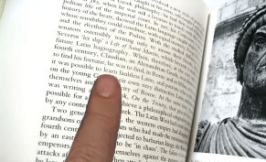
Tracking skills, or the ability to control the fine eye movements required to follow a line of print, are especially important in reading. Children with tracking problems will often lose their place, skip or transpose words, and have difficulty comprehending because of their difficulty moving their eyes accurately. Many are forced to use their fingers to follow the line because their eyes can't.
When we read, our eyes don’t move smoothly across the line. Instead, our eyes make a series of jumps and pauses as we read. The small jumps between words or groups of words are called saccades. The brief pause we make while looking at the words is called a fixation. After a fixation, we move our eyes to the next word or group of words—another saccade.
This very precise coordination of jumps and pauses is controlled by our central and peripheral visual systems. Our central vision processes what we’re seeing in clear detail and defines what we’re looking at. Our peripheral, or side vision, simultaneously locates surrounding objects and let’s us know where to look. (These two systems are sometimes referred to as the "Where is it?" and "What is it?" systems.) In reading, our central vision processes the word, while our side vision locates the following word and tells us where to aim our eyes next. The integration of these two systems is what allows us to efficiently move our eyes along a line of print without overshooting or undershooting, or mistakenly aiming our eyes at lines above or below. If there is not continuous, fluid, simultaneous integration between these two systems, reading will be jerky, loss of place will be common, and comprehension will be poor.
Children with tracking problems can't control their eye movements at close ranges. The following is an example of how their eyes move during reading, especially as they fatigue:
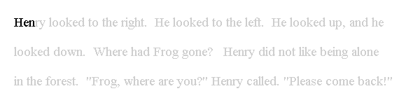
http://www.childrensvision.com/reading.htm

